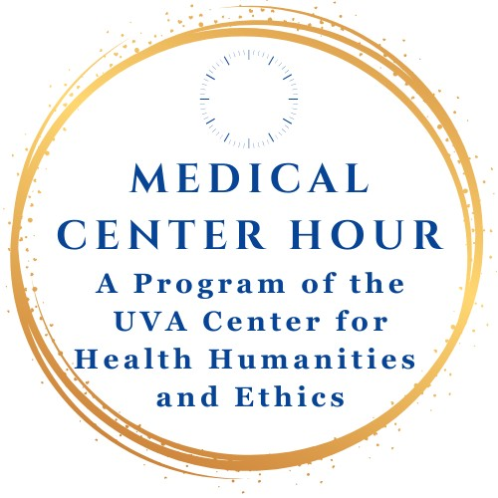
University of Virginia School of Medicine
Provided by the University of Virginia School of Medicine and School of Nursing

All programs scheduled from 12:00 to 1:00 pm.

Spring 2025

Wednesday, 26 March- In-person with Zoom hybrid, 12:00 to 1:00 pm, UVA Claude Moore Medical Education 3rd Floor Auditorium, Zoom: https://us02web.zoom.us/j/89105967067
A John F. Anderson Memorial Lecture
First Do No Harm, Then Do Good; A Deep Dive On Sustainable Healthcare
Jonathan B. Perlin, MD, PhD, MSHA, MACP, FACMI, Pres. & CEO, The Joint Commission, Washington, DC
Co-presented with

Wednesday, 09 April- In-person with Zoom hybrid, UVA Claude Moore Medical Education Learning Center, Zoom: https://us02web.zoom.us/j/89105967067
UVA Alpha Omega Alpha (AOA) Honor Medical Society
Continuity within Chaos: Caring for Individuals Living Chronically in Shelters and on the Streets
Jim O’Connell, MD, President, Boston Health Care for the Homeless Program and Assistant Professor of Medicine, Harvard Medical School
Co-presented with the UVA Alpha Omega Alpha (AOA) Honor Medical Society

Monday, 14 April- In-person with Zoom hybrid, 12:00 to 1:00 pm, UVA Pinn Hall Conference Center Auditorium, Zoom: https://us02web.zoom.us/j/89105967067
Speaking Up About Meaningful Work: Navigating Its Power and Pitfalls
Andrew Soren, Founder and CEO of Eudaimonic by Design
Co-presented with UVA Compassionate Care Initiative

Wednesday, 23 April- In-person with Zoom hybrid, UVA Claude Moore Medical Education Learning Studio, Zoom: https://us02web.zoom.us/j/89105967067

Beth Macy, Author, Dopesick: Dealers, Doctors, and the Drug Company that Addicted America

Medical Center Hour is free of charge and open to the public. For more information, see Center for Health Humanities and Ethics: https://med.virginia.edu/biomedical-ethics/medical-center-hour/

Watch Medical Center Hour recordings at:
https://www.youtube.com/user/UVAMCH

