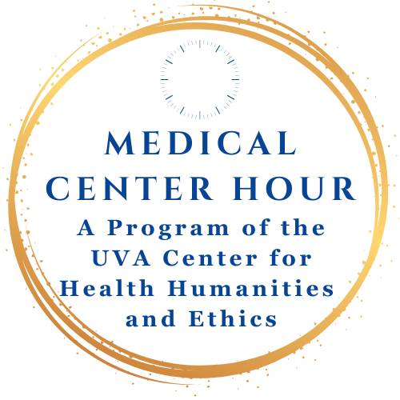
Wednesday, September 10, 2025 | 12:00 to 1:00
In Person at the Leonard Sandridge Auditorium (McKim Hall)
Zoom: https://us02web.zoom.us/j/89105967067

Jessie Stewart Richardson Memorial Lecture in Patient Quality and Safety
The Leader's Role in Generating Operational and Qualitative Excellence



MICHAEL N. BUNDY, MBA
Senior Advisor, Value Capture

This session, The Leader’s Role in Generating Operational Excellence, explores how consistent execution of routine clinical practices—such as infection prevention bundles, timely lab follow-up, and hourly rounding—directly improves patient safety and outcomes. Drawing on lessons from healthcare and the military principle that “good units do routine things, routinely,” the presentation highlights the physician’s role in building a culture of reliability and excellence. Participants will learn how transparent scorecards, safety huddles, and real-time operational metrics can be used not only to improve care delivery but also to teach and mentor the next generation of physicians.
Provided by the University of Virginia School of Medicine and School of Nursing

Lunch will be provided for the first 30 people in attendance after the program. No food or beverages are allowed in the auditorium

Michael Bundy is Senior Advisor at Value Capture, LLC. Prior to his time at Value Capture, beginning in 2019 he began serving as Chief Executive Officer for both Baptiste and Baptiste Parkridge hospitals and surrounding campuses in Columbia, SC. Since that time his, his CEO role expanded to also include Richland Hospital and campus in Columbia Tuomey Hospital and campus in Sumter - in sum, all four campuses in Prisma Health’s Midlands market.

Course Description: This series will address High-Level trends and expectations in accreditation in graduate medical education in internal medicine. It will discuss Gaps in care reflected in medical center quality data, priorities, and outcomes as well as trends and changes in patient care practice seen at UVA. Finally, we will cover topics from the clinical practice of Endocrinology, Nephrology and General Medicine that require additional representation due to the prevalence of education in other conference settings on other specialty areas in Internal Medicine.
Target Audience: Physicians, Residents
Desired Outcomes:
At the conclusion of this activity, participants should be able to:
- Incorporate new guidelines, techniques, and recent research into clinical practice based on the concepts shared in this series.
- Discuss current clinical cases in the context of evidence-based medicine to identify appropriate screenings and treatments for patients.
- Improve healthcare outcomes by regularly and frequently engaging the healthcare team in up-to-date and evidence-based education.
- the maintenance, improvement, and broadening of knowledge and skills throughout your professional life through attendance at this regularly scheduled series.
- Incorporate systems-based and practice-based processes to improve patient safety and quality in healthcare.
- Communicate effectively with clinical colleagues by incorporating interprofessional discussion techniques and patient-centered strategies, as appropriate.
- Analyze published outcome results and apply to current


Accreditation & Designation Statements:

In support of improving patient care, the University of Virginia School of Medicine and School of Nursing is jointly accredited by the Accreditation Council for Continuing Medical Education (ACCME), the Accreditation Council for Pharmacy Education (ACPE), and the American Nurses Credentialing Center (ANCC), to provide continuing education for the healthcare team.

The University of Virginia School of Medicine and School of Nursing designates this live activity for a maximum of 1 AMA PRA Category 1 Credit.TM Physicians should claim only the credit commensurate with the extent of their participation in the activity.
Successful completion of this CME activity, which includes participation in the evaluation component, enables the participant to earn up to 1 MOC point in the American Board of Internal Medicine’s (ABIM) Maintenance of Certification (MOC) program. It is the CME activity provider’s responsibility to submit participant completion information to ACCME for granting ABIM MOC credit.
The University of Virginia School of Medicine and School of Nursing awards 1 hour of participation (consistent with the designated number of AMA PRA Category 1 CreditTM or ANCC contact hours) to a participant who successfully completes this educational activity. The University of Virginia School of Medicine and School of Nursing maintains a record of participation for six (6) years.

Full Disclosure Policy Affecting CME Activities: As a joint accredited provider, the University of Virginia Office of CME/CE requires attested and signed global disclosure of the existence of all financial interests or relationships with commercial interest from any individual in a position to control the content of a CME activity sponsored by OCME.
No one in a position to control the content of this educational activity has disclosed a relevant financial interest or relationship with any commercial interest. Disclosure of faculty financial affiliations The University of Virginia School of Medicine and School of Nursing as a Joint Accreditation Provider adhere to the ACCME Standards for Integrity and Independence in Accredited Continuing Education, released in December 2020, as well as Commonwealth of Virginia statutes, University of Virginia policies and procedures, and associated federal and private regulations and guidelines. As the accredited provider for this CE/IPCE activity, we are responsible for ensuring that healthcare professionals have access to professional development activities that are based on best practices and scientific integrity that ultimately supports the care of patients and the public. All individuals involved in the development and delivery of content for an accredited CE/IPCE activity are expected to disclose relevant financial relationships with ineligible companies occurring within the past 24 months (such as grants or research support, employee, consultant, stock holder, member of speaker’s bureau, etc.). The University of Virginia School of Medicine and School of Nursing employ appropriate mechanisms to resolve potential conflicts of interest and ensure the educational design reflects content validity, scientific rigor and balance for participants. Questions about specific strategies can be directed to the University of Virginia School of Medicine and School of Nursing of the University of Virginia, Charlottesville, Virginia. The faculty, staff and planning committee engaged in the development of this CE/IPCE activity in the Joint Accreditation CE Office of the School of Medicine and School of Nursing have no financial affiliations to disclose.
Disclosure of discussion of non-FDA approved uses for pharmaceutical products and/or medical devices As a Joint Accreditation provider, the University of Virginia School of Medicine and School of Nursing, requires that all faculty presenters identify and disclose any off-label or experimental uses for pharmaceutical and medical device products. It is recommended that each clinician fully review all the available data on new products or procedures prior to clinical use.
How to Claim Your CE Credit via Text
To enter credit, text the Activity ID code below to the indicated phone number each time you attend.
Text To: 1 (855) 474-8287
Activity ID Code: 28173
This code will change for each session.
- You will receive a text confirmation that your “attendance has been recorded” for the activity.
- If you receive the message: “User not found in system,” text your email address to the same number, and your cell phone will then be connected with your CE account. Re-text the code above to record your attendance. New to UVA CE? If you have never attended a UVA CE course, create a new account at CMEVillage.com, then follow the above instructions to claim credit. How long do I have to text for credit? You may claim credit via text 15 minutes prior and 7 days after each session.
- Download the
Mobile App
- Download the CloudCME app from the Apple or Google App store.
- Enter Organization Code: UVA
- Log into your account
- Select Claim Credit, then enter the Course Code.

How can I claim credit without my phone?
Sign in to your account at CMEVillage.com.
    - UVA Employees: Log-in with UVA Computing ID and password.
    - Non-Employees: Log-in with your Email and Password.
      - Don’t know your password? Select “Forgot Your Password.”
      - First Time attending a UVA CE Course? Select “Sign Up Now.”
For assistance or questions with CE in CloudCME:
Email uvace@uvahealth.org. We’re here to help!

Medical Center Hour is free of charge and open to the public. For more information, see Center for Health Humanities and Ethics: https://med.virginia.edu/biomedical-ethics/medical-center-hour/

