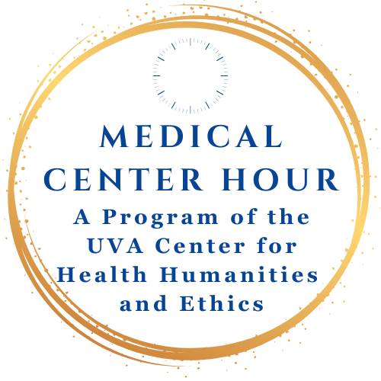
Wednesday, September 24, 2025 | 12:15 to 1:15
In Person at the Pinn Hall Conference Center Auditorium
Zoom: https://us02web.zoom.us/j/89105967067
The Center for Excellence in Education/Education Grand Rounds
Shame Competence: What it is, Why we need it, and How it can Transform Healthcare Institutions



Speaker: Will Bynum, MD, PhD, Associate Professor of Family Medicine
Director, The Shame Lab, Duke University School of Medicine
Will Bynum, MD, PhD is an Associate Professor of Family Medicine at Duke University School of Medicine and a Veteran of the United States Air Force. He received his M.D. at the University of South Carolina School of Medicine in 2010, completed his residency in the NCC Family Medicine Residency with the US Air Force, and received his Ph.D. in Health Professions Education at Maastricht University in the Netherlands in 2023, where defended his thesis entitled “Out of the shadows: a qualitative exploration of shame in medical learners”, which was awarded best Doctoral Dissertation by the Association of Medical Education in Europe. He is Co-Founder and Co-Director of The Shame Lab, which conducts research, develops training, and delivers consultancy to advance constructive engagement with shame in professional practice.

Lunch will be provided for the first 30 people in attendance after the program.

