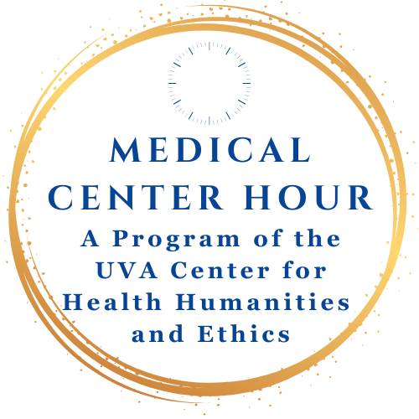
Thursday, October 30, 2025 | 12:00 to 1:00
In Person at the Pinn Hall Conference Center Auditorium
Zoom: https://us02web.zoom.us/j/89105967067

Koppaka V. Rao Memorial Lecture
Cochlear Implants, Curative Rhetoric, and Communication Choices: Understanding the Complications of Patient Decisions



Rachel Kolb, Ph.D., author of Articulate: A Deaf Memoir of Voice

Rachel Kolb was born profoundly deaf in 1990, the same year that the Americans with Disabilities Act was passed. She grew up with both American Sign Language (ASL) and spoken and written English, as well as the newfound accessibility measures that enabled her to thrive in school and other settings. But when she was twenty years old, she decided to get a cochlear implant (CI) in one ear. At the time, this felt like one of the most loaded — and indeed one of the most ambivalent — decisions of her life.

In this reflective talk, Kolb will give a personal account of her decision to get a CI, fleshing out how she reckoned with both medical and cultural frameworks of deafness, alongside the varied ways she’d already learned to think about language and human communication. Drawing from her new book Articulate: A Deaf Memoir of Voice, she will introduce clinicians to some complications with curative rhetoric in the medical setting, including how the commonplace desire to “fix” disability can sometimes limit medical professionals’ understanding of individuals’ deeper perspectives and lived experiences. Finally, she will consider how her CI became another tool in her daily arsenal, alongside the many other communication choices that can empower effective interpersonal understanding, including in clinical contexts.
Provided by the University of Virginia School of Medicine and School of Nursing

Lunch will be provided for the first 50 people in attendance.

Rachel Kolb is a writer whose work explores communication, language, and disability as central components of human experience. A graduate of Stanford University, she was the first signing deaf Rhodes scholar at Oxford before receiving her Ph.D. in English literature from Emory University and then completing a junior fellowship in the Society of Fellows at Harvard University. Her work has been published in The New York Times and The Atlantic, among other venues, and she is the author of the new memoir Articulate (Ecco, 2025).

Course Description: This series will address High-Level trends and expectations in accreditation in graduate medical education in internal medicine. It will discuss Gaps in care reflected in medical center quality data, priorities, and outcomes as well as trends and changes in patientcare practice seen at UVA. Finally, we will cover topics from the clinical practice of Endocrinology, Nephrology and General Medicine that require additional representation due to the prevalence of education in other conferences on other specialty areas in Internal Medicine.
Target Audience: Physicians, Nurses, UVA Faculty, Staff, and Students
Desired Outcomes:
- Incorporate new guidelines, techniques, and recent research into clinical practice based on the concepts shared in this series.
- Discuss current clinical cases in the context of evidence-based medicine to identify appropriate screenings and treatments for patients.
- Improve healthcare outcomes by regularly and frequently engaging the healthcare team in up-to-date and evidence-based education.
- Promote the maintenance, improvement, and broadening of knowledge and skills throughout your professional life through attendance at this regularly scheduled series.
- Incorporate systems-based and practice-based processes to improve patient safety and quality in healthcare.
- Communicate effectively with clinical colleagues by incorporating interprofessional discussion techniques and patient-centered strategies, as appropriate.
- Analyze published outcome results and apply to current cases to inform the appropriate treatment of patients and practice of medicine.

Presentation Objectives:
- Describe the distinctions between medical and cultural frameworks of deafness
- Discuss some of the complexities of cochlear implantation technology and decision-making, drawing from a patient’s perspective
- Reflect upon medical “enhancement” vs. “cure,” especially given the complications of “curative” rhetoric in the lived experiences of people with disabilities

Accreditation & Designation Statements:
In support of improving patient care, UVA Health Continuing Education is jointly accredited by the Accreditation Council for Continuing Medical Education (ACCME), the Accreditation Council for Pharmacy Education (ACPE), and the American Nurses Credentialing Center (ANCC), to provide continuing education for the healthcare team.

UVA Health Continuing Education designates this live activity for a maximum of 1 AMA PRA Category 1 Credits.TM Healthcare Professionals should claim only the credit commensurate with the extent of their participation in the activity.

UVA Health Continuing Education awards 1 contact hour for nurses who participate in this educational activity and complete the post activity evaluation.
UVA Health Continuing Education awards 1 hour of participation (consistent with the designated number of AMA PRA Category 1 Credit(s)TM or ANCC contact hours) to a participant who successfully completes this educational activity.
UVA Health Continuing Education maintains a record of participation for six (6) years.

Full Disclosure Policy Affecting CME Activities: As a joint accredited provider, UVA Health Continuing Education requires attested and signed global disclosure of the existence of all financial interests or relationships with commercial interest from any individual in a position to control the content of a CME activity sponsored by UVACE.
Disclosure Summary:
No one in a position to control the content of this educational activity has disclosed a relevant financial interest or relationship with any commercial interest
Medical Center Hour is free of charge and open to the public. For more information, see Center for Health Humanities and Ethics: https://med.virginia.edu/biomedical-ethics/medical-center-hour/


How to Claim Your CE Credit via Text
How to Text to Claim Credit
To enter credit, text the Activity ID code below to the indicated phone number each time you attend.
Text To: 1 (855) 474-8287
Activity Code: 28175
This code will change for each session.
- You will receive a text confirmation that your “attendance has been recorded” for the activity.
- If you receive the message: “User not found in system,” text your email address to the same number and your cell phone will then be connected with your CE account. Then, re-text the code above to claim credit.
- New to UVA CE? If you have never attended a UVA CE course, create a new account at CMEVillage.com, then follow the above instructions to claim credit.
How long do I have to text for credit?
You may claim credit via text 15 minutes prior and until 7 days after each session.
 Download the
Mobile App
Download the CloudCME app from the Apple or Google App store.
Enter Organization Code: UVA
Log into your account
Select Claim Credit, then enter the Course Code.
If you are viewing this presentation as a pre-recorded video, you will not be able to claim credit.
How can I claim credit without my phone?
Sign in to your account at CMEVillage.com.
    - UVA Employees: Log-in with UVA Computing ID and password.
    - Non-Employees: Log-in with your Email and Password.
      - Don’t know your password? Select “Forgot Your Password.”
      - First Time attending a UVA CE Course? Select “Sign Up Now.”
Need Assistance with CloudCME?
Contact: uvace@uvahealth.org. We’re here to help!
References:
- The Art of Flourishing: Conversations on Disability (eds. Liz Bowen, Joel Michael Reynolds, Rosemarie Garland-Thomson, and Erik Parens; Oxford University Press, 2025)
- Sensory Futures: Deafness and Cochlear Implant Infrastructures in India (Michele Friedner; University of Minnesota Press, 2022)
- About Us: Essays from the Disability Series of the New York Times (eds. Peter Catapano and Rosemarie Garland-Thomson; Liveright, 2019)
- Deaf Identities: Exploring New Frontiers (eds. Irene Leigh and Catherine O’Brien; Oxford University Press, 2019)

