Mental Health Emergency + Crisis Services
UVA Department of Student Health and Wellness (SHW)

All UVA students are eligible for emergency assessments and/or consultation.
[
]
FOR LIFE-THREATENING EMERGENCIES: Call 911 from on or off Grounds.
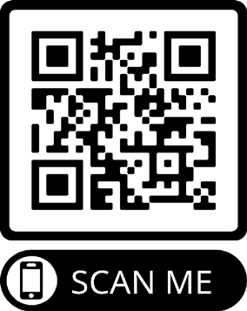
The UVA Health Emergency Room is located at 1215 Lee St, Charlottesville, VA 22908

24/7: TalkNow through TimelyCare via Phone or Video
TalkNow allows you to virtually meet with an urgent care counselor 24 hours a day, 7 days a week through the TimelyCare web or mobile app platform. Follow these easy steps to get connected:
- Go to timelycare.com/uva. Download the TimelyCare app or use their web-based platform.
- Use your @virginia.edu student email address to sign up.
- Click “Get Care”
- Click TalkNow and follow the instructions on the screen
- Experiencing connection or technical difficulties? Call (833) 484-6359 (monitored 24/7)
Students may walk in to SHW Counseling & Psychological Services (CAPS) to meet with the counselor on-call every Monday through Friday, 8:30 AM - 4:30 PM. A CAPS on-call counselor is also available for emergency consultation by phone every Monday through Friday from 8:30 AM - 4:30 PM.
For an emergency walk-in consultation:
- CAPS is located on the fourth foor of the Student Health and Wellness building at 550 Brandon Ave.
- The SHW building is accessible by foot, bus, bike, and car. Patient parking is available. Use these directions for directional guidance and parking information for the SHW building.
To connect with the on-call counselor by phone:
  - Call CAPS at (434) 243-5150
  - Ask to speak with the counselor on-call.
24/7 Telehealth (Phone or Video): TalkNow through TimelyCare Service at CAPS
Monday - Friday, 8:30am to 4:30pm: Emergency Walk-In Consultation or Phone

24/7: Concerns About a Student
Faculty, staff, parents, or community members concerned about a student who needs immediate attention can call:
- The Offce of the Dean of Students (ODOS) Dean On-Call for non-clinical crisis support:
  - During business hours (M-F, 8-5): (434) 924-7133
  - After-hours + weekends, emergencies and urgent concerns: (434) 924-7166
- CAPS On-Call for confdential, clinical support: (434) 243-5150

Additional Crisis Response and Support
- Sexual Assault Resource Agency (SARA): (434) 977-7273
- Unwanted Sexual Encounter: www.studenthealth.virginia.edu/unwanted-sexual-encounter
- National Suicide Prevention Lifeline: 1 (800) 784-2433 or 1 (800) 273-8255
- Crisis Text Line: Text HOME to 741741. Students of Color can text STEVE to 741741.
- Trevor Lifeline (LGBTQ): (866) 488-7386 or text “trevor” to 202-304-1200 (7 Days/Week, 3pm–10pm EST).
- Region Ten Emergency Services: (434) 972-1800

