**Center for Excellence in Education Scholars Program: Call for Self-nominations for 2025-2026 Cohort**

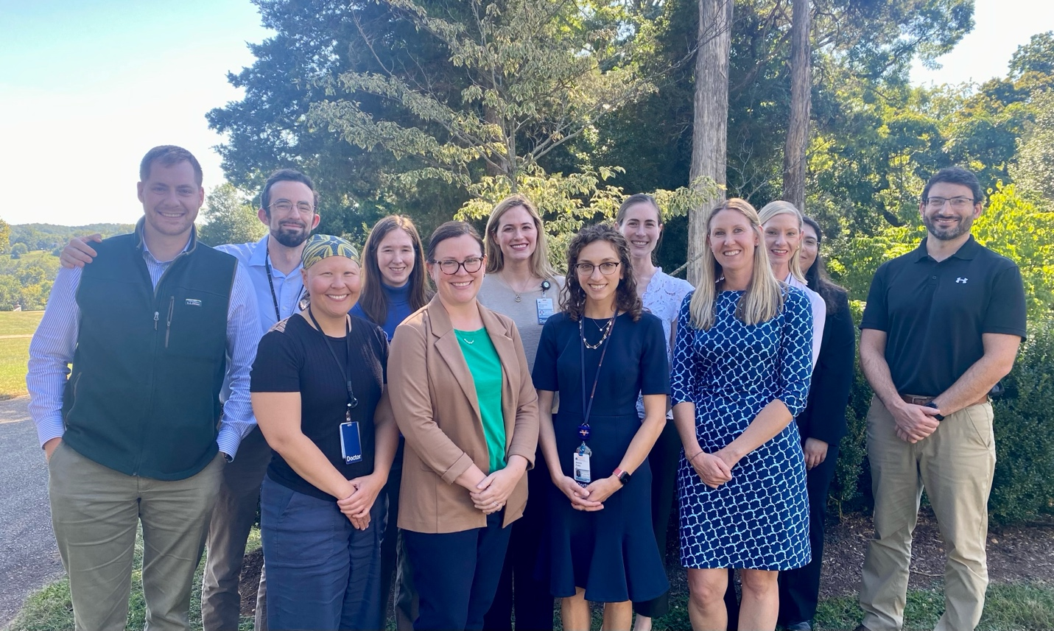

*2024-2025 Center for Excellence in Education Scholars*

The Center for Excellence in Education (CEE) at UVA School of Medicine is pleased to announce that we are recruiting for the 3rd cohort of the CEE Scholars Program.

**What?** The purpose of the CEE Scholars Program is to advance excellence through development of faculty expertise in educational scholarship. Through faculty and peer mentorship, formal training around core educational scholarship topics, and longitudinal feedback regarding a project of the scholar’s choosing, this cohort program targets faculty in the School of Medicine seeking to advance their training in educational scholarship. The formal curriculum will include presentations and discussion on topics including: literature review, theoretical frameworks, research question development, assessment/outcomes, program evaluation, curriculum development, methodology (quantitative, qualitative and mixed methods), survey design, dissemination, funding, and career development.

**Why?** This program is designed to provide mentorship and formal training around educational scholarship. Graduates will be in position to submit their completed work for dissemination at local, regional, and national conferences and peer-reviewed journals. They will also be competitive for intramural and extramural funding opportunities.

**Who?** The intended audience is any faculty educator who is dedicated to the teaching mission and would like to build expertise in health professions education scholarship.

**When?** Applications may be submitted until April 25, 2025 using this [link.](https://virginia.az1.qualtrics.com/jfe/form/SV_3dX9oanljf3jHjU)  Notifications will be disseminated by May 16, 2025. The program will begin in September of 2025. In-person meetings will be held for one half-day each month (on Tuesdays) from September through May 2025-2026. Scholars will then have several months to implement their projects with continued mentorship from departmental and CEE leaders. The program will conclude with a recognition ceremony in December of 2026.

|  |
| --- |
| **SESSION DATES (Tuesdays)** |
| September 9th |
| October 7th |
| November 11th |
| December 2nd |
| January 13th |
| February 10th |
| March 17th |
| April 14th |
| May 5th |
| June 2nd |
| June 23rd  (extra session) |
| December 2026 |

**How much?** Free! We require commitment to attend a once/month meeting (1/2 day) from September 2025 through June 2026 in addition to arranging meetings with mentors at a mutually agreeable time. No financial commitment is required.

Questions? Contact [Michael S. Ryan, MD, MEHP,](mailto:michael.ryan@virginia.edu) Professor of Pediatrics, Director of the Center for Excellence in Education.