Office of Sponsored Programs Higher Education Crisis Financial Impact Tracker FAQs

General
What is the Higher Education Crisis Financial Impact Tracker app?
What information will be entered into the Higher Education Crisis Financial Impact Tracker app?
Do I need to access the app if none of my grants were impacted by COVID-19?
Are there resources available for me to help in assessing what costs I can report as an estimated loss?
I am a Principal Investigator. How do I access the Higher Education Crisis Financial Impact Tracker app using a mobile device?
I am a Principal Investigator. How do I access the Higher Education Crisis Financial Impact Tracker app using a laptop?
I am a Research Administrator. How do I access the Higher Education Crisis Financial Impact Tracker app?
Why am I getting the “AADSTS900023: Specified tenant identifier '7b3480c7-3707-4873-8b77-e216733a65ac:' is neither a valid DNS name, nor a valid external domain” error message when I attempt to access the app?
How frequently will I have to submit information using the app?
What if, as a PI, I don’t submit the information for myself or my employees?
How can I tell the status of which grants have been reported and which haven’t?
Whom do I contact if I have questions?

Personnel Costs
Are there are examples of how estimated losses associated with personnel costs should be calculated?
Can impact percentages and impact reasons be reported across pay periods for a given sponsored project?
May I submit the impact percentages and impact reasons for multiple employees at one time within a given pay period?

What if I have no estimated losses for personnel costs but I have losses for OTPS costs?

OTPS Costs
I am a Principal Investigator. Do I have to enter my estimated losses for OTPS costs?
How do I estimate the losses associated with OTPS expenditures?
How do I report estimated losses for OTPS expenditures if a refund has been received for an expenditure?
May I upload just one spreadsheet with the OTPS expenditures for the sponsored program rather than one spreadsheet for each fiscal period?
What if I have no estimated losses for OTPS costs but I have estimated losses for personnel costs?

General
What is the Higher Education Crisis Financial Impact Tracker app?
The Financial Impact tracker app allows users to report the estimated percentage of impact associated with sponsored projects due to the COVID-19 pandemic or any other crisis. Specifically, the app is currently used to document the exceptional costs incurred under the flexibilities granted due to COVID-19 for OMB and federal grant making agencies. It is meant to be simple and intuitive.

What information will be entered into the Higher Education Crisis Financial Impact Tracker app?
The app will capture the estimated impact on personnel and “Other Than Personal Services” (OTPS) costs charged to grants since March 2020.

Are there resources available for me to help in assessing what costs I can report as an estimated loss?
In determining which costs to consider in assessing estimated losses (both for personnel and non-personnel costs), PIs should refer to the following resources:
OMB Memo M-20-18: Managing Federal Contract Performance Issues Associated with the Novel Coronavirus (COVID-19)

COGR
https://www.cogr.edu/institutional-and-agency-responses-covid-19-and-additional-resources

NIH
https://grants.nih.gov/faqs#/covid-19.htm?anchor=alphaHeader4203

NSF
https://www.nsf.gov/bfa/dias/policy/covid19/covid19faqs_m2026proposerandawardee.pdf

Please review the federal guidelines provided via OMB memorandums M-20-11 (expired on 7/26/2020), M-20-17 and M-20-20 (rescinded with the issuance of M-20-26 on 6/18/2020). OMB Memo M-20-26 (expired on 9/30/2020), states awarding agencies may allow recipients to continue to charge salaries and benefits to active Federal awards consistent with the recipients' policy of paying salaries, under unexpected or extraordinary circumstances, from all funding sources, Federal and non-Federal. Federal awarding agencies may allow other costs to be charged to Federal awards necessary to resume activities supported by the award, consistent with applicable Federal cost principles and the benefit to the project. The recipients need to exhaust other available funding source to sustain its workforce and implement necessary steps to save overall operational costs (such as rent renegotiations) during this pandemic period in order to preserve federal funds for the ramp-up effort. Recipients should retain documentation of their efforts to exhaust other funding sources and reduce overall operational costs.

Do I need to access the app if none of my grants were impacted by COVID-19?
Yes, you will need to log in to the app even if none of your grants were impacted. Upon logging in, the Welcome page will display:
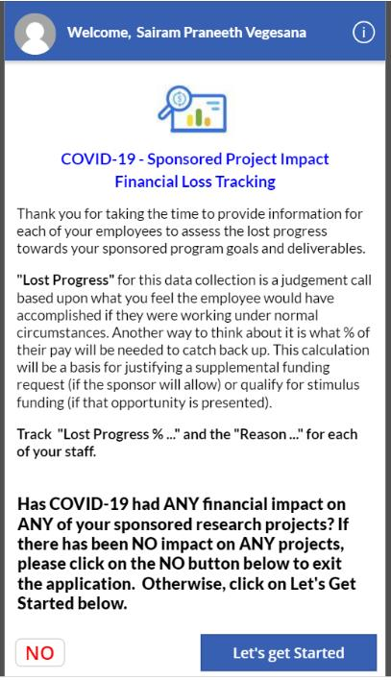

Simply select “NO” in the bottom left-hand corner and the response will be recorded in the database. The following message will appear at the top of your screen:
You will then be automatically logged out of the app.
Remember – selecting the “NO” button is an “all or nothing” action. It should be used only if there was no impact across all of the PI’s sponsored programs since March. If even one sponsored program was impacted for one fiscal or pay period, the “NO” button should not be selected.

I am a Principal Investigator. How do I access the Higher Education Crisis Financial Impact Tracker app using a mobile device?
Select the link corresponding to the mobile device you will be using to download and install Microsoft Power Apps:
For Apple devices using iOS, access the App Store
For Android devices, access Google Play
After you install the Power Apps Mobile, open the app from your device and sign in with your University credentials (use your “virginia.edu” e-mail account and eservices password).
Select the “Higher Education Crisis Financial Impact Tracker” app.

I am a Principal Investigator. How do I access the Higher Education Crisis Financial Impact Tracker app using a laptop?
If you will be accessing the app using a laptop, use either Google Chrome or Mozilla Firefox, and open an incognito window in your browser. Do not use Microsoft Internet Explorer (IE) or Microsoft Edge.
Provided below are examples of how to open an incognito window in (1) Google Chrome, (2) Mozilla Firefox.

Google Chrome:
1
Select the ellipsis located at the far right of the browser page.
2
Select “New Incognito window.”

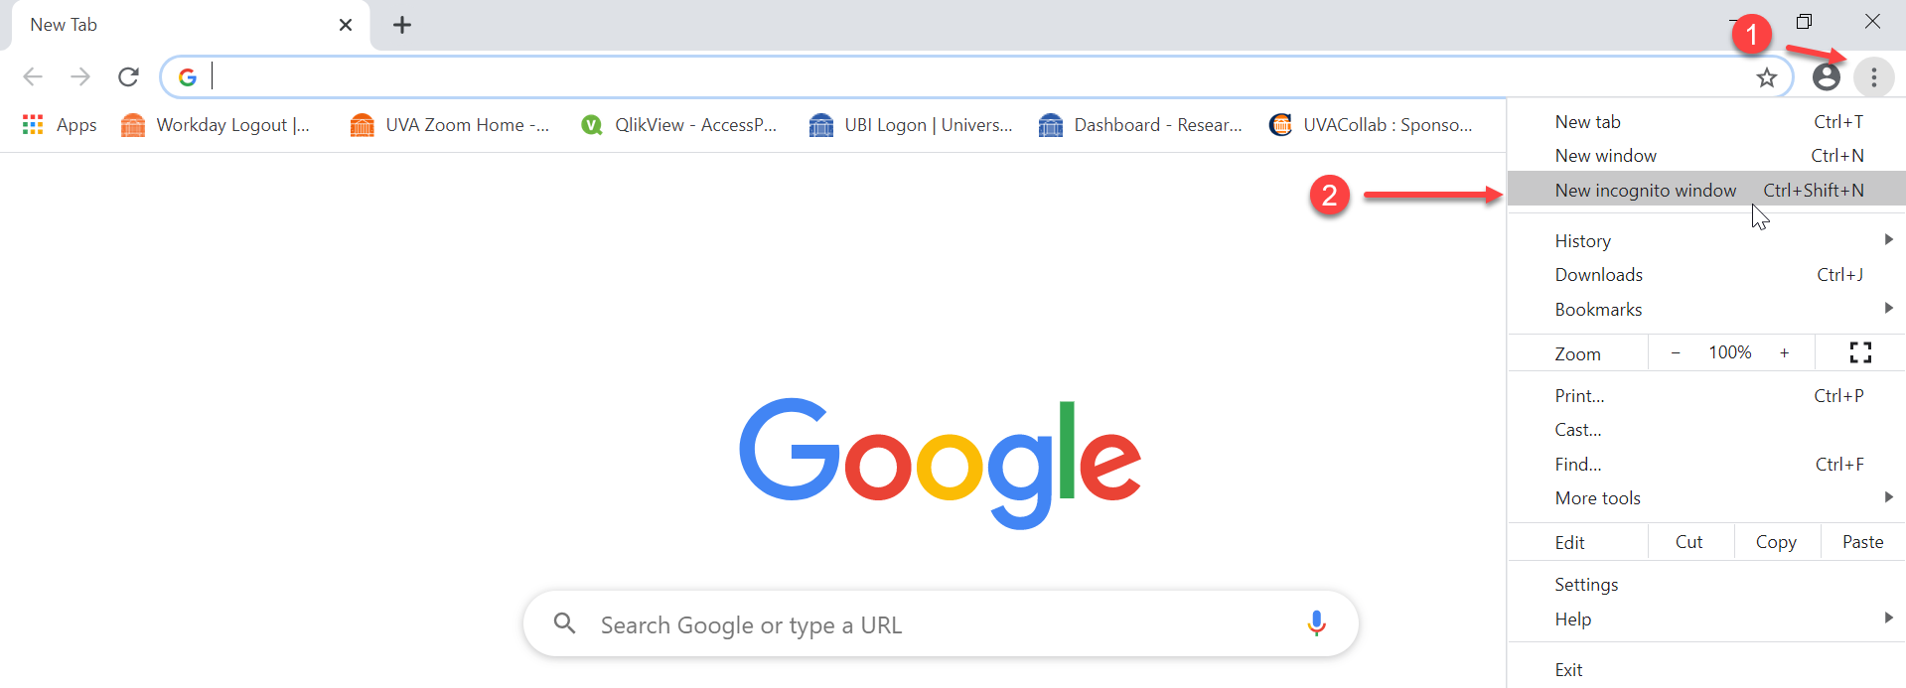

Paste in the following link:
https://apps.powerapps.com/play/beb09ac5-149e-4164-ad1a-0ab2b45d6498?tenantId=7b3480c7-3707-4873-8b77-e216733a65ac:

The Financial Impact Tracking app is part of the UVA Academic Office 365 environment. You will need your eservices password to access the app.

If prompted, select “Work or school account.”
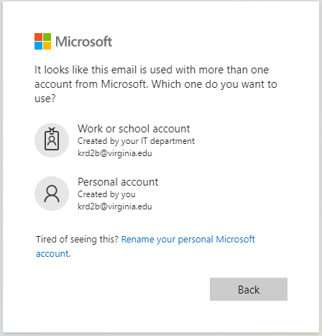
Sign in using your University credentials (use your “computingID@virginia.edu” e-mail account and eservices password.) If you experience password issues while signing in with computingID@virginia.edu, or you normally sign in to a different domain (HealthSystem) and you don't know your eservices password, this document will take you through the steps necessary to reset it:

https://virginia.service-now.com/its/?id=itsweb_kb_article&sys_id=2f47ff87dbf6c744f032f1f51d961967

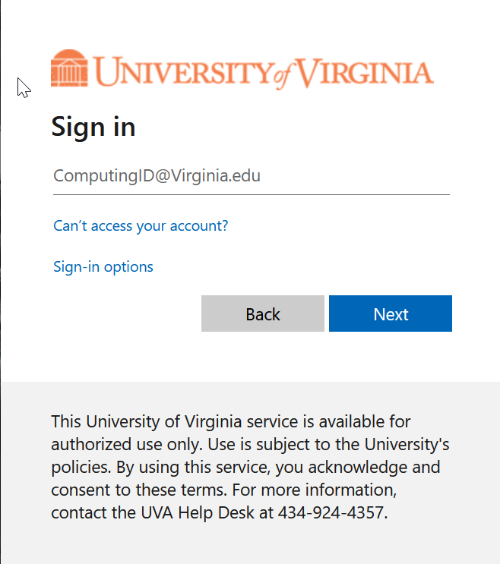

Complete the DUO 2 factor challenge for access.
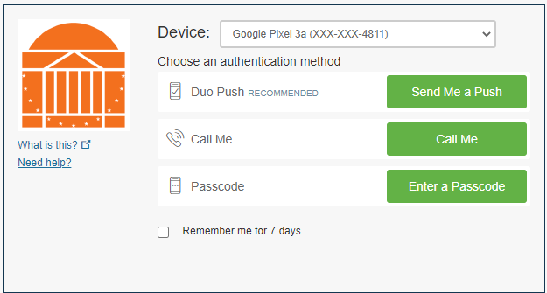
If you have any problems, please call 4 HELP (434-924-4357) for assistance.

Mozilla Firefox:
1
Select the menu with the three bars at the far right of the browser page.
2
Select “New Private Window.”

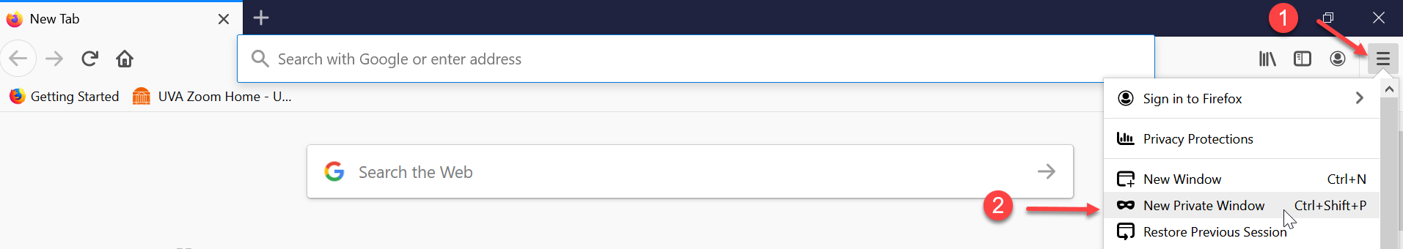

Paste in the following link:
https://apps.powerapps.com/play/beb09ac5-149e-4164-ad1a-0ab2b45d6498?tenantId=7b3480c7-3707-4873-8b77-e216733a65ac:
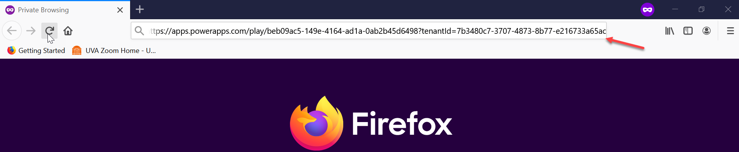
The Financial Impact Tracking app is part of the UVA Academic Office 365 environment. You will need your eservices password to access the app.

If prompted, select “Work or school account.”

Sign in using your University credentials (use your “computingID@virginia.edu” e-mail account and eservices password.) If you experience password issues while signing in with computingID@virginia.edu, or you normally sign in to a different domain (HealthSystem) and you don't know your eservices password, this document will take you through the steps necessary to reset it:

https://virginia.service-now.com/its/?id=itsweb_kb_article&sys_id=2f47ff87dbf6c744f032f1f51d961967

Complete the DUO 2 factor challenge for access.

If you have any problems, please call 4 HELP (434-924-4357) for assistance.

I am a Research Administrator. How do I access the Higher Education Crisis Financial Impact Tracker app?
You will receive an e-mail with a link to the PowerBI report, which contains the app. You will be able to access all of the sponsored programs for Principal Investigators in your school or unit, based upon security roles that have been established. It is critical that if you are keying data for the faculty member, that you sit with them and get the PI’s information. The PI is the only person who should be setting the percentage of loss values for personnel or estimating losses for OTPS costs.
Paste the link into a Google Chrome incognito window or Mozilla Firefox private window. Do not use Microsoft Internet Explorer (IE) or Microsoft Edge.
You will then see this screen:
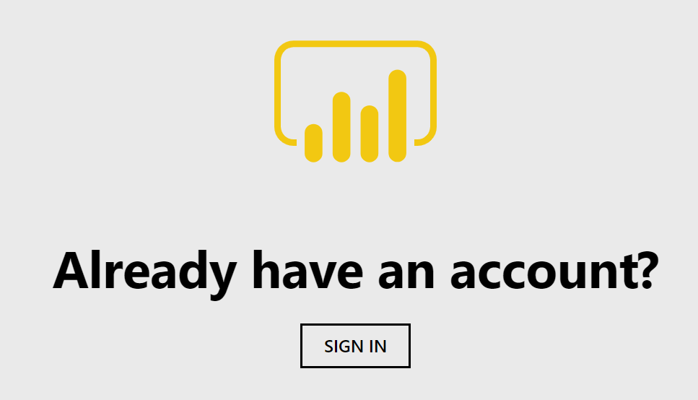
Select “Sign In.”
Sign in using your University credentials (use your “computingID@virginia.edu” e-mail account and eservices password.) If you experience password issues while signing in with computingID@virginia.edu, please go to the identity portal at https://identity.virginia.edu/identity/self-service/uva/autologin.jsf to reset your eservices password.

Why am I getting the “AADSTS900023: Specified tenant identifier '7b3480c7-3707-4873-8b77-e216733a65ac:' is neither a valid DNS name, nor a valid external domain” error message when I attempt to access the app?
If you are a researcher but are not named as the Project PI on any project in Oracle, you will encounter that error.

How frequently will I have to submit information using the app?
This application is designed to capture data by month/period. Data will need to be entered for every month in the application.

What if, as a PI, I don’t submit the information for myself or my employees?
Use of this system is critical to collect the information federal agencies are expecting UVA to be able to provide. Compliance is in your best interest, as well as the University’s best interest.

How can I tell the status of which grants have been reported and which haven’t?
Research Administrators have access to two tabs in the PowerBI report. One will show the status for reporting estimated losses associated with personnel costs; the other will show the status for reporting estimated losses associated with OTPS costs.

Whom do I contact if I have questions?
Please send an e-mail to osp-apphelp@virginia.edu if you have any questions about the app.

Personnel Costs

Are there are examples of how estimated losses associated with personnel costs should be calculated?
It is important to understand what impact percentage we are asking you to provide. It is your best estimate of the percent of time “lost”/”impact” that COVID has had on your research. If you estimate a loss of 10% in the month of March, since we didn’t get closed down until mid-March, then you would enter 10% for March. The data is by period (month), so you may put 50% for April, let’s say, or 100% if you believe that to be true, 60% for May and 70% for June, etc. Whatever you deem as your best estimate is what you should include for each period for all periods available in the dropdown box.
It is important to note, this has no correlation to the percent of effort you promised to the sponsor. It is the percent of impact of time lost from your perspective during the COVID shutdown.
Percentages should be entered as a whole number (e.g., 50% would be entered as ’50,’ rather than ‘0.5’) based on the assessment or judgement that you make for the period you are entering the data.

Keep in mind that these are judgement calls based on your best estimate using the information you have available. NOTE: Please ensure this data correlates with representations included in any progress report that has been filed or will be filed with the sponsor.

Can impact percentages and impact reasons be reported across pay periods for a given sponsored project?
No, the app was not designed to allow for reporting across pay periods. Impact percentages and reasons must be reported on a pay period by pay period basis.

May I submit the impact percentages and impact reasons for multiple employees at one time within a given pay period?

Yes, as long as the estimated impact percentage and impact reason are the same for the employees being reported for the given pay period, you may select all of the checkboxes associated with those employees and then select the Submit button, as in , below. You will then see those records updated, as in , below.
B
A

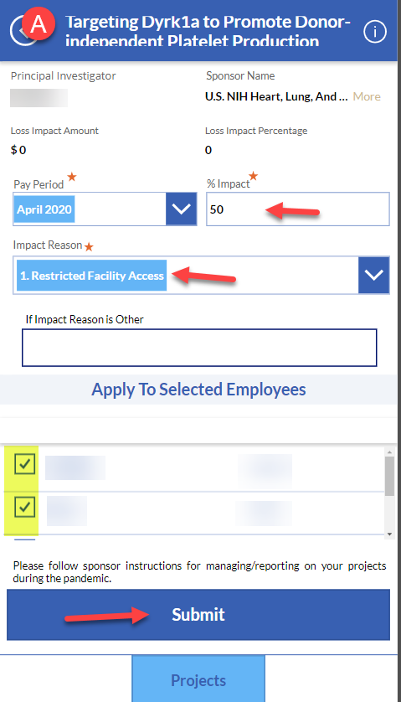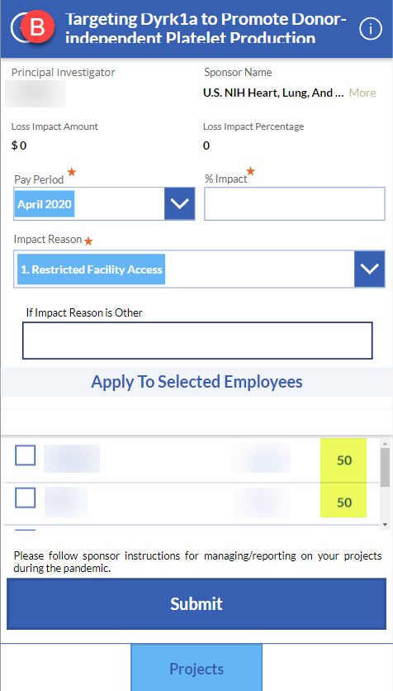

What if I have no estimated losses for personnel costs but I have losses for OTPS costs?
You should not select the “NO” button displayed on the Welcome screen of the app. You will need to select each sponsored project listed on the Personnel Costs form and then for each employee/pay period combination, you will need to report a 0% impact and select Impact Reason “0. No Impact.”

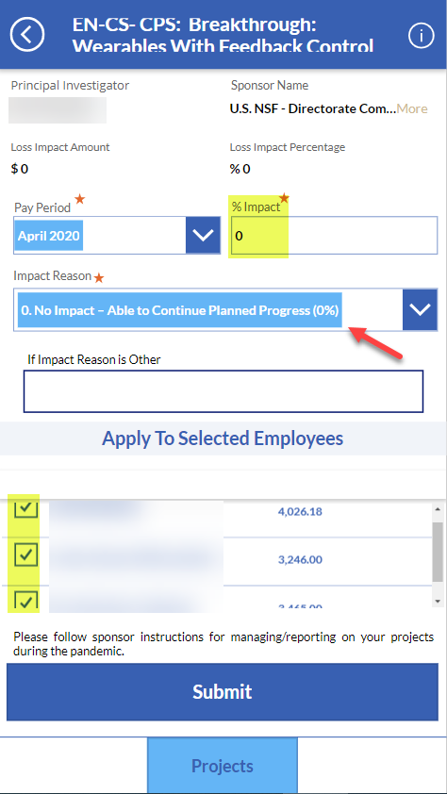

OTPS Costs

I am a Principal Investigator. Do I have to enter my estimated losses for OTPS costs?
No, the expectation is the PIs do not need to enter their estimated losses for OTPS costs. Research Administrators will be able to enter the data into the app on your behalf after you have provided them with the requisite information.

How do I estimate the losses associated with OTPS expenditures?
Based on what the Principal Investigator has explained in your discussions, please identify all expenditures, using the available UBI reports, which have an expenditure item date and transferred date after February 29, 2020. Once the impacted OTPS expenditures have been identified, sum the dollar values by fiscal period and enter the dollar amount of the monthly losses associated for each OTPS budget category.

How do I report estimated losses for OTPS expenditures if a refund has been received for an expenditure?
You will report the expenditure as a loss in the appropriate category in the month in which the charge posted to the sponsored program; the refund will likewise be reported in a similar manner in the month in which the credit posted to the sponsored program.

For example, suppose a PI purchased airline tickets in March 2020 costing $2,000 for a conference that was scheduled for April 2020. The conference was subsequently cancelled, and the airline refunded the full price of the ticket in July 2020.

Both the $2,000 cost that posted in March 2020 and the $2,000 credit that posted in July 2020 would be reported as an estimated loss in the Travel category for each month, as shown below:

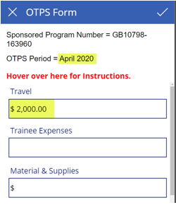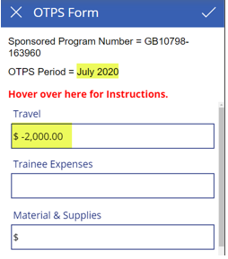

May I upload just one spreadsheet with the OTPS expenditures for the sponsored program rather than one spreadsheet for each fiscal period?
No, a spreadsheet containing the OTPS expenditures exported from UBI must be uploaded for each fiscal period and each sponsored program for which losses other than $0.00 were estimated.

What if I have no estimated losses for OTPS costs but I have estimated losses for personnel costs?
You should not select the “NO” button displayed on the Welcome screen of the app. You will need to go to the OTPS Form for each sponsored program/fiscal period combination and select the checkbox in the upper right-hand corner of the form. That action will record that there were no estimated losses for OTPS for the given sponsored program/fiscal period.

