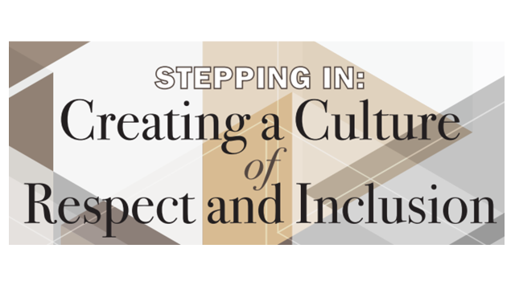
Workshop Overview:
This two-hour interactive workshop is designed to provide health system participants a framework for responding to situations where they experience or witness discriminatory behavior and create an opportunity to practice their responses.
Desired Outcomes:
Participants will learn how to respond appropriately to discriminatory behavior in three different scenarios:
(1) When a patient or family member exhibits discriminatory behavior,
(2) When a team member exhibits discriminatory behavior, and
(3) When a visitor to our health system exhibits discriminatory behavior
Registration/Participation:
For Departments, Centers and other teams, group registrations will be available. For individual learners, please contact Jann Balmer or Pamela Lace to register. Upon registration, participants will receive an email from SteppingIn4Respect with a link to the pre-workshop survey to complete prior to the beginning of the workshop. At the conclusion of the workshop, participants will receive another email with a link to the SteppingIn4respect web portal to the post-workshop survey. At 6-months post-workshop, they will receive an email with a link to the final survey. All of these surveys are treated as confidential, and there will be no identifiers linking their name or IDs to the survey responses.

Expectations for successful participation:
Due to the nature of this content, this workshop requires active engagement by all participants for the entire two-hour timeframe. Here are the overall expectations
- Access to video and audio access via Zoom
- Completion of the pre-workshop and post-workshop surveys
- Download the B.E.G.I.N framework and Circumplex handout
- Willingness to share insights and reactions to content
- Willingness to practice approaches to addressing discriminatory behavior
Currently all workshop sessions are being delivered via Zoom so the maximum number of participants/session is limited to 20.
Accreditation:
Accreditation and Designation Statement

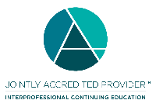
"In support of improving patient care, the University of Virginia School of Medicine and School of Nursing is jointly accredited by the Accreditation Council for Continuing Medical Education (ACCME), the Accreditation Council for Pharmacy Education (ACPE), and the American Nurses Credentialing Center (ANCC), to provide continuing education for the healthcare team."

AMA PRA CATEGORY 1 CREDIT
The University of Virginia School of Medicine and School of Nursing designates this live for a maximum of 2 AMA PRA Category 1 Credits.TM. Physicians should claim only the credit commensurate with the extent of their participation in the activity.

ANCC CONTACT HOURS
The University of Virginia School of Medicine and School of Nursing awards 2 contact hours for nurses who participate in this educational activity and complete the post activity evaluation.

ABMS Maintenance of Certification Part II and IV
All ABMS Board certified physicians who are interested in receiving Maintenance of Certification points through the ABMS Portfolio Program, for their participation in Stepping In 4 Respect need to complete the pre-workshop, post-workshop and 6 month follow up survey and complete the Attestation form provided by the Office of Continuing Medical Education. For questions please contact Pamela Lace.

ACPE CREDIT
Pharmacists and pharmacy technicians need to provide their NABP e-profile ID and DOB when logging into Tracker in www.cmevillage.com. This information is NOT needed to log onto the Stepping In 4 Respect web portal, to complete the pre and post-workshop and 6 month surveys and access resource materials for the workshop.

AAPA CME CREDIT
This activity is designated for 2 AAPA Category 1 CME credits. PAs should only claim credit commensurate with the extent of their participation.

APA CE CREDIT
Continuing Education (CE) credits for psychologists are provided through the co-sponsorship of the American Psychological Association (APA) Office of Continuing Education in Psychology (CEP). The APA CEP Office maintains responsibly for the content of the programs.

ASWB CREDIT
As a Jointly Accredited Organization, the University of Virginia School of Medicine and School of Nursing is approved to offer social work continuing education by the Association of Social Work Boards (ASWB) Approved Continuing Education (ACE) program. Organizations, not individual courses, are approved under this program. State and provincial regulatory boards have the final authority to determine whether an individual course may be accepted for continuing education credit. The University of Virginia School of Medicine and School of Nursing maintains responsibility for this course. Social workers completing this course receive 2 Social work CE credits.

ADA CERP CREDIT
The University of Virginia School of Medicine and School of Nursing designates this activity for 2 continuing education credits.

CDR CPEU CREDIT
Completion of this RD/DTR profession-specific or IPCE activity awards 1 CPEU/session. (One IPCE credit=One CPEU). If the activity id dietetics-related but not targeted to RDs or DTRs, CPEUs may be claimed which are commensurate with participation in contact hours (One 60 minute hour= 1 CPEU).
RD’s and DTRs are to select activity type 102 in their Activity Log. Performance Indicator selection is at the learner’s discretion.
Questions:
For questions regarding this workshop, please contact:
Jann Balmer (jbalmer@virginia.edu) or
Pamela Lace (PSL5G@virginia.edu)

Thank you

