parametric = continuous variable, bell curve distribution [MEANS]
non-parametric = distribution is not normal, categorical variables [MEDIANS]
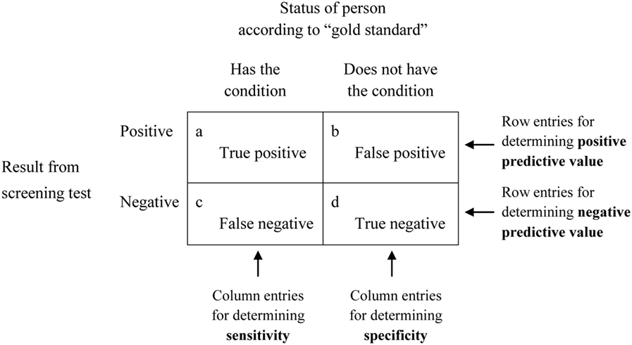
A sensitive test has few false negatives
Good for screening
(e.g., PSA)

A specific test has few false positives
Good for confirmation
(e.g., cytology)

Sensitivity=[a/(a+c)]×100Specificity=[d/(b+d)]×100Positive predictive value(PPV)=[a/(a+b)]×100Negative predictive value(NPV)=[d/(c+d)]×100.

[b/(b+d)]x100
[a/(a+c)]x100
Multivariable Modeling
-- Multivariable linear regression

(parametric)
* = paired test – use when comparing change in same subject (e.g., comparing weight before and after a diet intervention)
>2 groups
X² test
(Chi-squared)
If <5 in a subgroup…
Fisher’s Exact test
(Chi-squared)
Multivariable Modeling
-- Logistic regression
-- Cox proportional hazards (survival analysis)

Binary
(non parametric)
NOT normal distribution
*paired t-test
*Wilcoxon rank sum
Spearman’s
Kruskal-Wallis
Mann-Whitney U
Pearson’s or linear regression
Continuous
Comparisons
>2 groups
ANOVA
Correlation
Normal distribution
Dependent Variable
(D
Comparisons
OUTCOME
(D
t-test
2 groups

